|  |  |
| --- | --- |
|  | Version  2 |

All Hazards Waste Logistics Tool

U.S. Environmental Protection Agency

User’s Guide

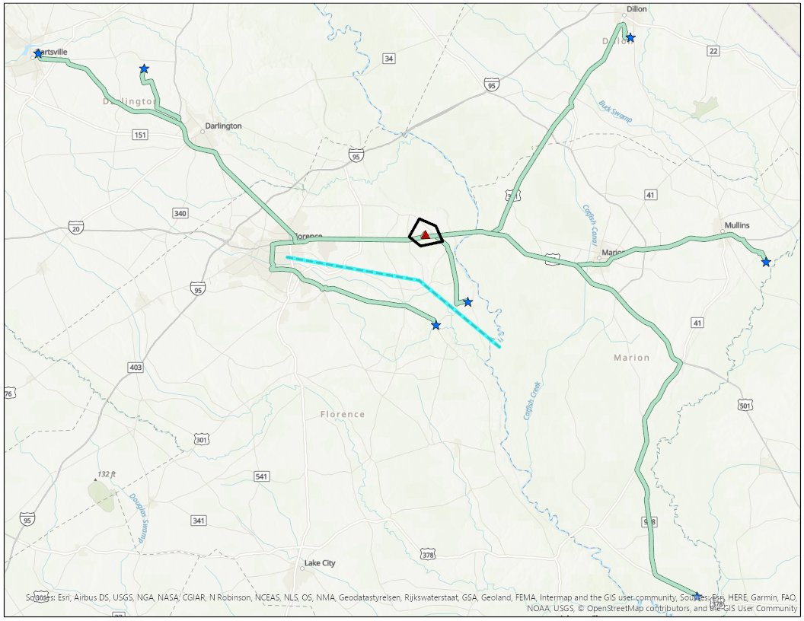

u.s. Environmental protection agency

ALL HAZARDS WASTE LOGISTICS TOOL, v2.0

Timothy Boe, Paul Lemieux

U.S. Environmental Protection Agency

Office of Research Development

Center for Environmental Solutions and Emergency Response

Research Triangle Park, NC 27711

Colin Hayes, Molly Rodgers, Paul Dziemiela

Eastern Research Group

Morrisville, NC 27560

Disclaimer

This tool was created by the U.S. Environmental Protection Agency through its Office of Research and Development’s Homeland Security Research Program (HSRP). The research described in this user guide has been funded by the U.S. Environmental Protection Agency (EPA) under contract EP-C-16-015. This document has been reviewed in accordance with U.S. Environmental Protection Agency policy and approved for publication. Any mention of trade names, manufacturers or products does not imply an endorsement by the United States Government or the U.S. Environmental Protection Agency. EPA and its employees do not endorse any commercial products, services, or enterprises. This is a work of the U.S. Government and is not subject to copyright protection in the United States. Contractor’s role did not include establishing Agency policy.

Acronym/Abbreviation List

| **Acronym** | **Definition** |
| --- | --- |
| AGO | ArcGIS Online |
| CBRN | chemical, biological, radiological, or nuclear |
| CWT | centralized waste treaters |
| DDRT | Disaster Debris Recovery Tool |
| ECHO | Enforcement and Compliance History Online |
| EPA | U.S. Environmental Protection Agency |
| FLIGHT | Facility Level Information on GreenHouse Gases Tool |
| FOTW | federally owned treatment works |
| FRA | Federal Railroad Administration |
| GIS | geographic information system |
| GVWR | gross vehicle weight ratings |
| HSRP | Homeland Security Research Program |
| HMIWI | Hazardous Medical Infectious Waste Incinerators |
| I-WASTE | Incident Waste Decision Support Tool |
| JSON | JavaScript object notation |
| LARW | low-activity radioactive waste |
| MACT | maximum achievable control technology |
| MSW | municipal solid waste |
| NESHAP | National Emission Standards for Hazardous Air Pollutants |
| NHAW | non-hazardous aqueous waste |
| PIV | personal identity verification |
| POTW | publicly owned treatment works |
| RAD | radioactive waste |
| RAM | random access memory |
| RCRA | Resource Conservation and Recovery Act |
|  |  |

**Table of Contents**

1. Introduction 1

How to Use This Guide 1

Point of Contact 2

Description 2

Systems Approach 3

1. Design and Methodology 4

Design Components 4

Methodology to Estimate Resource Demands 5

User Inputs 5

Adjustable User Inputs (Defining Scenario Conditions) 5

Guidance for Specifying Transporting Capacity 7

Resource Demand Calculations 8

Factors Sets 10

1. Installation and Setup 13

Minimum System and Software Requirements 13

Extract the Tool 13

Project Setup 13

1. Waste Storage and Disposal Locations 14

Default Disposal Facility Data 14

Default Facility Attribute Data 15

I-WASTE Refresh Tool 19

Export Facilities to a User-Defined Dataset 20

User-Defined Facilities 20

Staging and Storage Locations 21

1. Routing Network 22

Network Dataset Options 22

ArcGIS Pro License, Routing, and Network: Configuration Scenarios 23

Configuration Scenario #1 23

Configuration Scenario #2 24

Configuration Scenario #3 25

Configuration Scenario #4 26

1. Run the Tool 27

Load Project 27

Step 1: Create Work Environment 29

Review Work Environment Settings 31

Step 2: Define Scenario 33

Step 3: Set Scenario Conditions 34

Step 4: Set Transporter Attributes 34

Step 5: Draw Incident Area 35

Step 6: Draw Support Area 35

Step 7: Load Facilities to Network 36

Select Disposal Facility Types 36

Load I-WASTE Facilities 37

Load User-Defined Facilities 37

Exclude Facilities 38

Limit by Support Area 38

Truncate Existing Facilities 38

Adjust Quantity Accepted and Disposal Fees 38

Step 8: Draw Routing Barriers 39

Step 9: Solve Routing Scenario 39

Step 10: Eliminate Routes 40

Step 11: Calculate Logistics Planning Estimates 42

Specify Map Settings 43

Step 12: Export Planning Results 43

Results Output 43

Create and Compare More than One Scenario 44

1. Troubleshooting 45

**Appendix A – Facility Schema**

**List of Figures**

Figure 1. Icon Key 1

Figure 2. General Tool Workflow 2

Figure 3. Systems Thinking Approach for CBRN Incidents 3

Figure 4. All Hazards Waste Logistics Tool Design Components 4

Figure 5. I-WASTE Facility Refresh Tool 19

Figure 6. Export Facilities to a User-Defined Dataset 20

Figure 7. Configuration Scenario #1 Flow 23

Figure 8. Configuration Scenario #2 Flow 24

Figure 9. Configuration Scenario #3 Flow 25

Figure 10. Configuration Scenario #4 Flow 26

Figure 11. Authentication Examples 27

Figure 12. Open the All Hazards Waste Logistics Tool Tasks Pane 28

Figure 13. Create Work Environment Pane 29

Figure 14. Work Environment Settings 31

Figure 15. Edit Factor Set Example 32

Figure 16. Define Scenario Pane 33

Figure 17. Set Scenario Conditions Pane 34

Figure 18. Set Transporter Attributes Pane 34

Figure 19. Draw Incident Area Controls 35

Figure 20. Save Sketching - Pending Edits Alert 35

Figure 21. Draw Support Area Controls 36

Figure 22. Load Facilities to the Network Pane 36

Figure 23. Add User-Defined Facilities 37

Figure 24. Save Sketching - Pending Edits Alert 37

Figure 25. Draw Routing Barriers Tools 39

Figure 26. Solve Routing Scenario Pane 40

Figure 27. Eliminate Routes Editing Tools 41

Figure 28. Calculate Logistics Planning Estimates Pane 42

Figure 29. Map Settings 43

Figure 30. Export Logistics Planning Results Pane 43

**List of Tables**

Table 1. Modifiable Values for Scenario Conditions 6

Table 2. Modifiable Transporter Attribute Values for Scenario Conditions 6

Table 3. Truck GVWR Based on Classification 7

Table 4. Rail Car Capacities Based on Type 8

Table 5. CPLM Unit Rates, Road (*FCPLM*) 11

Table 6. CPLM Unit Rates, Rail (*FCPLM*) 11

Table 7. Fixed Transportation Costs, Road (*FTC*) 11

Table 8. Fixed Transportation Costs, Rail (*FTC*) 12

Table 9. Labor Cost (*FLC*) 12

Table 10. Minimum System and Software Requirements 13

Table 11. Default Facility Types and Sources 14

Table 12. Default Facility Daily Throughput Capacity 17

Table 13. Default Facility Disposal Fees 18

# Introduction



1

CHAPTER

Learn about this geographic information system (GIS) tool that applies spatial information and analysis technologies to evaluate resource demands associated with transporting large volumes of waste

Large-scale disasters have the potential to generate a significant amount of varying types of waste. For example, Hurricanes Katrina and Rita in 2005 resulted in 64.3 million cubic yards of debris in Louisiana, Mississippi managed an estimated 46 million cubic yards of debris from Hurricane Katrina, and the 2011 Joplin, Missouri tornado resulted in three million cubic yards of debris throughout the disaster area.[1] Accidental and intentional (e.g., terrorism, war) chemical, biological, radiological, or nuclear (CBRN) incidents have the potential to generate as much waste or more when compared to natural disasters. Recovery is profoundly impacted by waste management issues and the strategies selected to manage those issues.

The quantification, segregation of different waste types, transportation, and storage of waste can be an arduous and costly undertaking. Furthermore, these processes are intricately linked with the decisions made throughout the recovery timeline. Therefore, the remediation, including waste management, must be holistically considered. Understanding these complex interactions can be facilitated by using models and tools that adhere to the “system-of-systems” approach. To better understand and predict waste management issues, the U.S. Environmental Protection Agency’s (EPA’s) Homeland Security Research Program (HSRP) developed a suite of tools[2] and resources for planning and recovery purposes. EPA’s All Hazards Waste Logistics Tool uses spatial information and analysis techniques to support evaluating resource demands associated with transporting large volumes of waste. The tool was developed to help decision makers (e.g., state, local, tribal, and territorial governments and federal partners) better understand potential options, including cost and time tradeoffs, for managing waste and to illuminate potential capacity constraints, transportation considerations, and impact of waste categorization to inform increased preparedness.

## How to Use This Guide

Figure . Icon Key

The purpose of this guide is to provide the necessary information to operate the tool. Described in this guide are methods for installing, configuring, and operating the tool. It is **highly recommended** that users have previous experience with and a working knowledge of ArcGIS before operating the tool.

The “icon key” in 1 Figure 1contains symbols used throughout this guide to highlight important information and additional guidance.

## Point of Contact

Timothy Boe

U.S. EPA Office of Research and Development

Center for Environmental Solutions and Emergency Response   
Homeland Security and Materials Management Division  
919-541-2617 office | 919-541-0496 fax  
[boe.timothy@epa.gov](mailto:boe.timothy@epa.gov)

## Description

Tools that facilitate planning through scenario-based analyses are necessary to increase preparedness, identify problematic scenarios that might inform earlier decisions to alleviate constraints, and encourage discussions to identify effective solutions in advance of an incident. Two GIS-based tools that are available to supporting planning and response activities include:

* **Waste Staging and Storage Site Selection Tool**[3] uses spatial information and analysis techniques to support suitability analyses to identify candidate areas for consideration. The tool was developed to help decision makers better understand potential options for managing waste and to illuminate potential capacity constraints to inform increased preparedness. The tool analyzes siting criteria for a specified geographic area to identify candidate sites and their total available land surface areas to support waste management operations.

**All Hazards Waste Logistics Tool** addresses the need to evaluate the resource demands associated with transporting and disposing of large volumes of waste. The tool calculates the cost and time to manage a user-specified quantify of waste and allows users to run routing scenarios with user-defined destinations. Factors specific to waste type, transport mode, hauling rates, and waste management facility acceptance rates allow users to explore options and evaluate constraints to improve preparedness for managing large volumes of waste. The Waste Staging and Storage Site Selection Tool was designed to work in tandem with the All Hazards Waste Logistics Tool to identify potential staging locations for inclusion in the logistics decision-making process. Figure 2 below illustrates the general workflow of the tool.

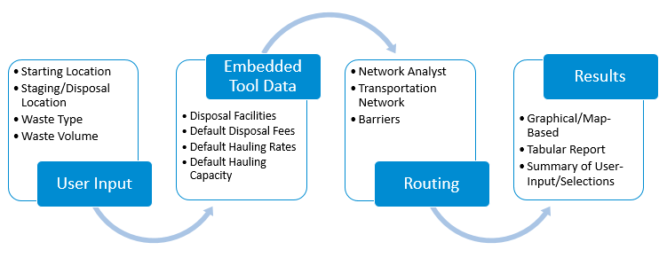

Figure 2. General Tool Workflow

## Systems Approach

For wide-area incidents, response and recovery efforts might begin without collecting or considering essential information. Decisions related to decontamination and waste management, including the disposal strategy, will affect the cost, duration, and effectiveness of the response. The process of understanding how these response activities influence one another and contribute to the overall solution is referred to as a systems approach. The systems approach recognizes that each response activity is coupled with another, where decisions made for one response action impact decisions and options that exist for another. For example, this dynamic is observed where the amount of waste to be managed is profoundly impacted by the decontamination approach that is selected, or when waste management constraints might drive decontamination decisions. Figure 3 demonstrates the balance of operations (e.g., planning, response, and recovery) versus available resources. This figure describes both the systems approach (i.e., processes are interrelated and impact one another) and the cost-benefit of decisions (i.e., the benefit of decisions and their impact on available resources). With time, operationally-driven decisions drive or tip the balance in favor of more resources. This approach typically causes remediation to become resource intensive in terms of cost and time (e.g., a specific decontamination method is costly, but is quicker). While EPA waste tools (e.g., Waste Estimation Support Tool) encourage a phased and cohesive approach (i.e., decontamination, waste estimation, and disposal), the tools compile and display results in a way that allow users to see the “big picture” and how small changes in these approaches can greatly impact each individual response activity.

This “big picture” approach facilitates planning through scenario-based analyses that can increase preparedness, identify problematic scenarios, and ultimately identify effective solutions in advance of an incident. The systems approach seeks to balance the overall resource demand by leveraging the system as a whole and predicting an optimal outcome, which in return provides greater insight and improves decision making. The All Hazards Waste Logistics Tool embodies this approach by allowing the users to see how their decisions impact other operations (e.g., the amount of waste generated as a function of decontamination and the classification of waste as it relates to waste disposal facility options) with regard to resource demand (e.g., cost and time).

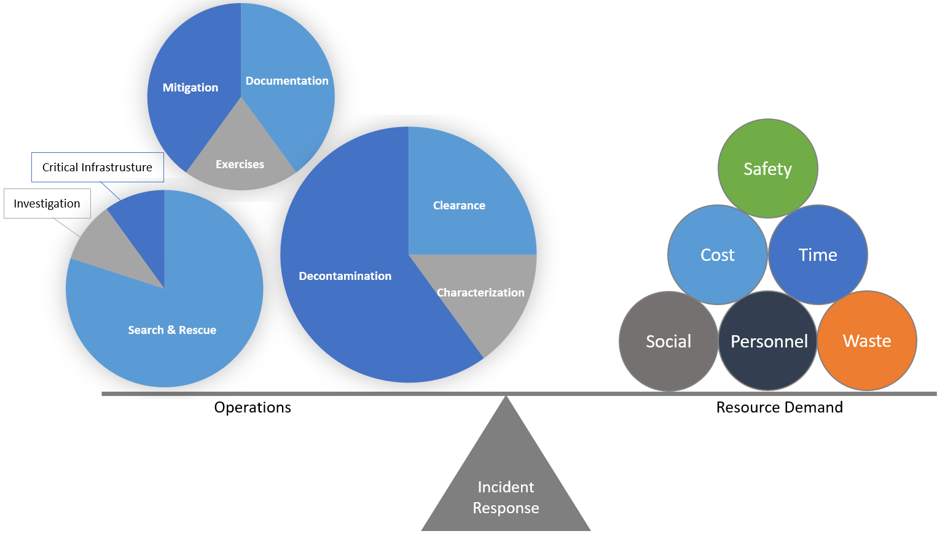

Figure 3. Systems Thinking Approach for CBRN Incidents

# Design and Methodology



2

CHAPTER

*Understand the tool’s underlying methodology, overall workflow, and default data and assumptions that impact results*

## Design Components

Esri’s ArcGIS Pro was used to develop the graphical user interface to support the estimation of resource demands associated with transporting large quantities of waste. ArcGIS allows users to: (1) interact with geoprocessing tools, map layers, datasets, and other data types, and connect them to a process; (2) iteratively process feature class modifications or attribute tables in a workspace; (3) visualize the workflow through a task-based user interface; and (4) leverage multiple geoprocessing tools that handle processing steps that are coded using Python scripting. Finally, the results are output into a Microsoft Excel dataset that captures the scenario conditions, computational results, and references to default factors used. Figure 4 illustrates the overall tool design.

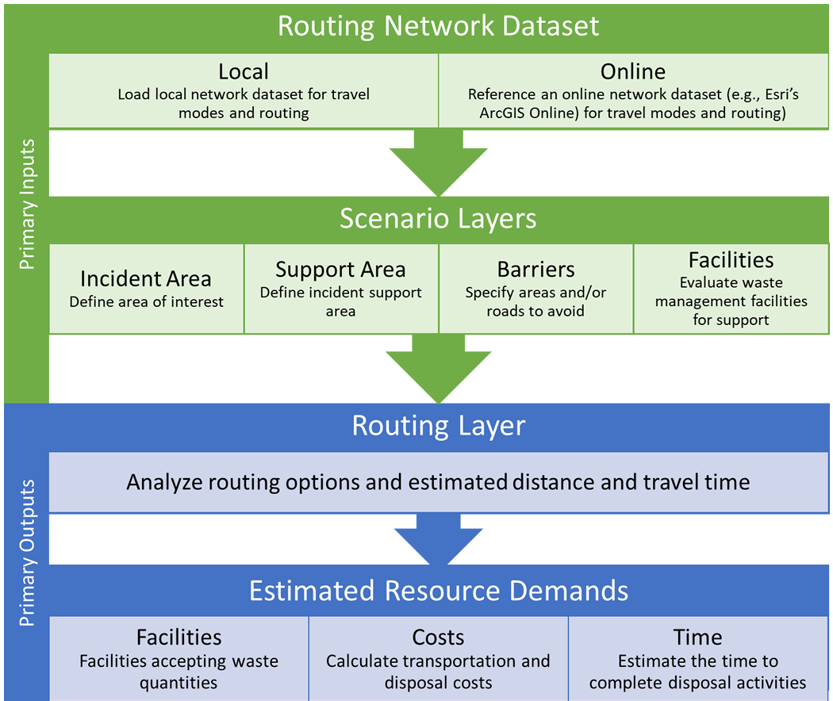

Figure 4. All Hazards Waste Logistics Tool Design Components

The tool is organized into a sequence of steps (described in Chapter 6 of this user’s guide) that guides the user through providing necessary inputs and specifying selections to calculate estimated resource demands for a scenario.

## Methodology to Estimate Resource Demands

Research was conducted to support estimating cost and time calculations related to transporting waste. Version 2 enhancements to the All Hazards Waste Logistics Tool now allow users to specify the volume of waste that a transporter container (either a truck or one or more train containers) can carry to a disposal or staging site. Transporter capacity can be modified as a user input. Representative carrying capacities of various truck sizes and a range of rail car types are provided in this guide to aid the user.

Factors were developed for ten waste type combinations and are specific to waste type and medium (i.e., solid or liquid):

1. Radioactive: Contact-Handled (Volume Solid or Volume Liquid)
2. Radioactive: Remote-Handled (Volume Solid or Volume Liquid)
3. Low-Activity Radioactive Waste (Volume Solid)
4. Hazardous (Volume Solid or Volume Liquid)
5. Municipal Solid Waste (MSW) (Volume Solid)
6. Construction and Demolition (C&D) (Volume Solid)
7. Non-Hazardous Aqueous Waste (Volume Liquid)

Solid waste amounts are in cubic yards or cubic meters (yd3 or m3), and liquid waste amounts are in gallons or liters (gal or L). Users specify the waste volume and type (i.e., medium) and the preferred system of units (metric or U.S. customary units). Unit conversions are performed, as needed, in the tool and are not reflected below. Resource demand calculations used within the tool are described below. The values provide a starting point and users can adjust the values (see Chapter 6 for guidance on how to change values) to better tailor waste disposal scenario conditions.

### User Inputs

*W* = Waste Volume (yd3 or m3 or gal or L, depending on the waste type)

*D* = Distance (mi or km)

*S* = Average Driving Speed (mi/h or km/h)

### Adjustable User Inputs (Defining Scenario Conditions)

*RT* = Road Tolls ($/shipment)

*MC* = Miscellaneous Costs ($/shipment)[4]

*TDC* = Transporter Decontamination Cost ($/shipment)

*SSC* = Staging Site Cost ($/day)

*TH* = Transporting Hours (h/day)

*TCM* = Total Cost Multiplier (additional percentage of total cost)3

*TCC =* Transporter Container Capacity (volume/container)

*NCT* = Number of Containers per Transporter (count)

*NTA* = Number of Transporters Available (transporters)

*TPD* = Transporters Processed per Day (transporters/day)

Table 1 presents modifiable values that can be tailored by the user. By default, additional cost values are set to $0; however, users can adjust values, as needed, to best reflect the scenario’s conditions. The tool provides a “high” condition set that can be used to assess resource demand differences. As described later in the guide, users can create and save condition sets to reference/use in subsequent analyses.

Table 1. Modifiable Values for Scenario Conditions

|  |  |  |  |
| --- | --- | --- | --- |
| Mode | Conditions | Default Value | High Value |
| Road | Road Tolls ($/shipment) | $0.00 | $50.00 |
| Miscellaneous Costs ($/shipment) | $0.00 | $0.00 |
| Transporter Decontamination Cost ($/shipment) | $0.00 | $1,000.00 |
| Staging Site Cost | $0.00 | $2,000.00 |
| Transporting Hours | 12 | 12 |
| Total Cost Multiplier (add % of Total Cost) | 25% | 25% |
| Rail | Miscellaneous Costs ($/shipment) | $0.00 | $0.00 |
| Transporter Decontamination Cost ($/shipment) | $0.00 | $1,000.00 |
| Staging Site Cost | $0.00 | $2,000.00 |
| Transporting Hours | 12 | 12 |
| Total Cost Multiplier (add % of Total Cost) | 25% | 25% |

Table 2 presents transporter attribute values that can be tailored by the user. The tool provides the following default attributes for truck and rail; however, users can adjust values, as needed, to best reflect the scenario’s conditions. These values are used, regardless of waste type; however, as described in Chapter 6, users can create multiple condition sets to model multiple instances of varying characteristics.

Table 2. Modifiable Transporter Attribute Values for Scenario Conditions

|  |  |  |  |
| --- | --- | --- | --- |
| Mode | Waste Medium | Transporter Attribute | Default Value |
| Road | Liquid | Transporter Container Capacity | 6,000 gal | 27,277 L |
| Solid | Transporter Container Capacity | 151 yd3 | 115 m3 |
| NA | Number of Containers per Transporter | 1 |
| NA | Number of Transporters Available | 30 |
| Liquid | Transporters Processed per Day | 15 |
| Solid | Transporters Processed per Day | 15 |
| Rail | Liquid | Transporter Container Capacity | 13,000 gal | 59,100 L |
| Solid | Transporter Container Capacity | 194 yd3 | 148 m3 |
| NA | Number of Containers per Transporter | 50 |
| NA | Number of Transporters Available | 1 |
| Liquid | Transporters Processed per Day | 1 |
| Solid | Transporters Processed per Day | 1 |

### Guidance for Specifying Transporting Capacity

The All Hazards Waste Logistics Tool allows users to specify the Transporter Container Capacity of a single transporter. To help users estimate their Transporter Container Capacity, information on the Gross Vehicle Weight Ratings (GVWR) of various truck sizes that could be used to transport waste (Table 3) and for the volumetric capacities of common rail car types that could be used to transport waste (Table 4) are provided. Truck weight ratings in Table 3 are in terms of GVWR in pounds and represent the total rated weight including the vehicle, passengers, fluids, and cargo. The cargo carrying capacities of vehicles within each classification vary according to the specific vehicle and the manufacture process. The “curb weight” is defined as the GVWR minus passengers and cargo and also is specific to individual vehicle makes and models. The GVWR is provided as a starting point for estimating the carrying capacity of a particular truck. By subtracting an estimated curb weight from a vehicle’s GVWR, users can estimate the vehicle’s carrying capacity (by weight, including passengers). Additionally, the density of the waste materials being carried can be accounted for in estimating the volumetric carrying capacity for a particular vehicle.

Table 3. Truck GVWR Based on Classification

|  |  |  |
| --- | --- | --- |
| **Truck Type** | **Truck Class #** | **Gross Vehicle Weight Ratinga** |
| **Light Duty** |  |  |
| Minivans, mini pick-up trucks | 1 | <6,000 lbs |
| Minivans, mini/full size pick-up trucks, utility vans | 2 | 6,001-10,000 lbs |
| Mini-bus, walk-in trucks, delivery trucks | 3 | 10,001-14,000 lbs |
| **Medium Duty** |  |  |
| Large walk-in vans, landscaping/utility vehicles | 4 | 14,001-16,000 lbs |
| Bucket truck, large delivery trucks | 5 | 16,001-19,500 lbs |
| School bus, beverage trucks, rack trucks | 6 | 19,501-26,000 lbs |
| **Large Duty** |  |  |
| Trash trucks, fuel/propane trucks, tow trucks, grapple trucks | 7 | 26,001-33,000 lbs |
| Trash trucks, fuel/propane trucks, tow trucks, dump trucks, tank trucks, semi-trucks, fire trucks | 8 | >33,000 lbs |

a <https://afdc.energy.gov/data/10380>

Table 4. Rail Car Capacities Based on Type

|  |  |  |
| --- | --- | --- |
| **Type** | **Freight Capacity (tons)** | **Volumetric Capacity (ft3 unless otherwise specified)** |
| 50-foot Standard Boxcara | 70-100 | 5,238 |
| 50-foot High-roof Boxcara | 100 | 6,269 |
| 60-foot Standard Boxcara | 70-100 | 6,085 |
| 60-foot High-roof Boxcara | 100 | 6,646 |
| 86-foot Auto Boxcara | 70 | 9,999 |
| Covered Hopper (Small Cube)a | 70-100 | 2,700-3,500 |
| Covered Hopper (Jumbo) a | 100-110 | 3,600-5,324 |
| Tank Carb | 263,000 or 286,000 lbs (Gross Rail Weight Limit, depending on contents and configuration) | 13,000-33,000 gallons |

a <https://www.csx.com/index.cfm/customers/resources/equipment/railroad-equipment/>

b <https://crdx.com/railcars/tankcars/>

### Resource Demand Calculations

**Number of Waste Shipments (*N*)**

= Waste Volume (yd3 or m3, or gal or L, depending on the waste type)/Transporter Capacity (yd3 or m3/shipment, or gal or L/shipment, depending on the waste type)

= *W* / *TC*

**Transporter Capacity (TC)**

= Transporter Container Capacity (TCC) x Number of Containers per Transporter (NCT)

**Transportation Cost per Loaded Mile (CPLM) Cost ($) (*CCPLM*)**

= Number of Waste Shipments x Distance (mi) x CPLM Unit Rates ($/mi)

= *N* x *D* x *FCPLM*(see Tables 5 and 6 “CPLM Unit Rates” below)

**Fixed Cost for Transportation ($) (*CF*)**

For Road:

* Radioactive: Contact-Handled (Solid)
* Radioactive: Contact-Handled (Liquid)
* Radioactive: Remote-Handled (Solid)
* Radioactive: Remote-Handled (Liquid)
* Low-Activity Radioactive Waste (Solid)

Fixed Cost ($)

= Waste Volume (yd3 or m3, or gal or L, depending on the waste type) x Fixed Unit Transportation Cost[5] ($/yd3 or $/m3, or $/gal or $/L)

= *W* x *FTC* (see Table 7)

For Road:

* Hazardous (Solid)
* Hazardous (Liquid)
* MSW (Solid)
* C&D (Solid)
* Non-Hazardous Aqueous Waste (Liquid)

Fixed Cost ($)

= Number of Waste Shipments x Distance (mi or km) x [2 (for round trip)/Average Driving Speed (mi/h or km/h)] x Fixed Unit Transportation Cost ($/h)

= *N* x *D* x 2/*S* x *FTC* (see Table 7)

For Rail:

* Radioactive: Contact-Handled (Solid)
* Radioactive: Contact-Handled (Liquid)
* Radioactive: Remote-Handled (Solid)
* Radioactive: Remote-Handled (Liquid)
* Low-Activity Radioactive Waste (Solid)
* Hazardous (Solid)
* Hazardous (Liquid)
* MSW (Solid)
* C&D (Solid)
* Non-Hazardous Aqueous Waste (Liquid)

Fixed Cost ($)

= Number of Containers per Transporter x Number of Waste Shipments x Fixed Unit Transportation Cost ($/container)

= *NCT* x *N* x *FTC* (see Table 8)

**Tolls ($) (*CRT*)**

= Road Tolls ($/shipment) x Number of Waste Shipments x 2 (for round trip)

= *RT* x *N* x 2

**Misc Costs ($) (*CMisc*)**

= Miscellaneous Costs ($/shipment) x Number of Waste Shipments

= *MC* x *N*

**Total Transportation Cost ($) (*CTRANS*)**

= *CCPLM* + *CF* + *CRT* + *CMisc*

**Time to Complete Transportation of Waste (days) (*TT*)**

= Distance (mi or km) x [2/Average Speed (mi/h or km/h)] / Transporting Hours (h/day) x (Number of Waste Shipments / Number of Transporters Available)

= *D* x [(2/*S)*/*TH*] x (*N*/*NTA*)

**Destination Time to Complete Transportation (days) (*TD*)**

= Number of Waste Shipments/Shipments Processed per Day (shipments/day)

= *N* / *TPD*

**Total Transportation Time (days) (*T*)**

= MAX(*TT*,*TD*)

**Waste Staging Site Cost ($) (*CSS*)**

= Total Transportation Time (days) x Staging Site Cost ($/day)

= *T* x *SSC*

**Waste Disposal Cost ($) (*CD*)**

= Waste Volume x Disposal Fees ($/waste volume)

= W x *FDC* (see Table 13)

**Labor Cost ($) (*CL*)**

= Number of Waste Shipments x Distance (mi or km) x [2 / Average Speed (mi/h or km/h)] x Labor Cost ($/h)

= *N* x *D* x (2/ *S)* x *FLC* (see Table 9)

**Transporter Decontamination Cost ($) (*CTD*)**

= Number of Waste Shipments x Transporter Decontamination Cost ($/shipment)

= *N* x *TDC*

**Additional Cost Due to Multiplier ($) (*CM*)**

= (Total Transportation Cost ($) + Waste Staging Site Cost ($) + Waste Disposal Cost ($) + Labor Cost ($) + Transporter Decontamination Cost ($)) x (Total Cost Multiplier (%) / 100)

= (*CTRANS* + *CSS* + *CD* + *CL* + *CTD*) x (*TCM* / 100)

**Total Cost ($) (*C*)**

= Total Transportation Cost ($) + Waste Staging Site Cost ($) + Waste Disposal Cost ($) + Labor Cost ($) + Transporter Decontamination Cost ($) + Additional Cost Due to Multiplier ($)

= *CTRANS* + *CSS* + *CD* + *CL* + *CTD* + *CM*

### Factors Sets

The tool relies upon additional default factors to support calculations. The values used are described in Tables 5-9. Each scenario is based on a “set” of four factors for a selected waste type. Chapter 6 provides details on how to alter the default factors included in the tool.

**Table 5. CPLM Unit Rates, Road (*FCPLM*)**

|  |  |  |  |
| --- | --- | --- | --- |
| **Waste Type** | ***Less than 30 mi***  **($/mi)** | ***30-200 mi***  **($/mi)** | ***More than 200 mi***  **($/mi)** |
| Radioactive: Contact-Handled (Solid) | 5.94 | 4.98 | 4.00 |
| Radioactive: Contact-Handled (Liquid) | 5.94 | 4.98 | 4.00 |
| Radioactive: Remote-Handled (Solid) | 11.70 | 7.85 | 4.90 |
| Radioactive: Remote-Handled (Liquid) | 11.70 | 7.85 | 4.90 |
| Low-Activity Radioactive Waste (Solid) | 5.94 | 4.98 | 4.00 |
| Hazardous (Solid) | 3.00 | 2.50 | 1.95 |
| Hazardous (Liquid) | 3.00 | 2.50 | 1.95 |
| MSW (Solid) | N/A | N/A | N/A |
| C&D (Solid) | N/A | N/A | N/A |
| Non-Hazardous Aqueous Waste (Liquid) | N/A | N/A | N/A |

N/A = Not Applicable

**Table 6. CPLM Unit Rates, Rail (*FCPLM*)**

|  |  |  |  |
| --- | --- | --- | --- |
| **Waste Type** | ***Less than 1,000 mi***  **($/mi)** | ***1,000-2,000 mi***  **($/mi)** | ***More than 2,000 mi***  **($/mi)** |
| Radioactive: Contact-Handled (Solid) | 2.32 | 1.91 | 1.60 |
| Radioactive: Contact-Handled (Liquid) | 2.32 | 1.91 | 1.60 |
| Radioactive: Remote-Handled (Solid) | N/A | N/A | N/A |
| Radioactive: Remote-Handled (Liquid) | N/A | N/A | N/A |
| Low-Activity Radioactive Waste (Solid) | 2.32 | 1.91 | 1.60 |
| Hazardous (Solid) | 1.96 | 1.74 | 1.46 |
| Hazardous (Liquid) | 1.96 | 1.74 | 1.46 |
| MSW (Solid) | N/A | N/A | N/A |
| C&D (Solid) | N/A | N/A | N/A |
| Non-Hazardous Aqueous Waste (Liquid) | N/A | N/A | N/A |

N/A = Not Applicable

**Table 7. Fixed Transportation Costs, Road (*FTC*)**

|  |  |  |  |  |  |
| --- | --- | --- | --- | --- | --- |
| **Waste Type** | **$/yd3** | **$/m3** | **$/gal** | **$/L** | **$/h** |
| Radioactive: Contact-Handled (Solid) | 37.20 | 48.60 | N/A | N/A | N/A |
| Radioactive: Contact-Handled (Liquid) | N/A | N/A | 0.1840 | 0.0486 | N/A |
| Radioactive: Remote-Handled (Solid) | 650.50 | 850.80 | N/A | N/A | N/A |
| Radioactive: Remote-Handled (Liquid) | N/A | N/A | 3.22 | 0.8510 | N/A |
| Low-Activity Radioactive Waste (Solid) | 37.20 | 48.60 | N/A | N/A | N/A |
| Hazardous (Solid) | N/A | N/A | N/A | N/A | 55.90 |
| Hazardous (Liquid) | N/A | N/A | N/A | N/A | 55.90 |
| MSW (Solid) | N/A | N/A | N/A | N/A | 55.90 |
| C&D (Solid) | N/A | N/A | N/A | N/A | 55.90 |
| Non-Hazardous Aqueous Waste (Liquid) | N/A | N/A | N/A | N/A | 55.90 |

N/A = Not Applicable

**Table 8. Fixed Transportation Costs, Rail (*FTC*)**

|  |  |
| --- | --- |
| **Waste Type** | **$/container** |
| Radioactive: Contact-Handled (Solid) | 750.00 |
| Radioactive: Contact-Handled (Liquid) | 750.00 |
| Radioactive: Remote-Handled (Solid) | N/A |
| Radioactive: Remote-Handled (Liquid) | N/A |
| Low-Activity Radioactive Waste (Solid) | 750.00 |
| Hazardous (Solid) | 750.00 |
| Hazardous (Liquid) | 750.00 |
| MSW (Solid) | 750.00 |
| C&D (Solid) | 750.00 |
| Non-Hazardous Aqueous Waste (Liquid) | 750.00 |

N/A = Not Applicable

**Table 9. Labor Cost (*FLC*)**

|  |  |
| --- | --- |
| **Type** | **$/h** |
| Road | 21.39 |
| Rail | 19.37 |

# Installation and Setup



3

CHAPTER

Review step-by-step instructions to install and set up the All Hazards Waste Logistics Tool

This chapter explains how to install and set up the tool. Before installation, user should confirm that their system meets or exceeds the recommended hardware and software requirements.

## Minimum System and Software Requirements

Table 10 describes the minimum system requirements and required software for the tool. Meeting the minimum system requirements does not guarantee that the tool will operate as intended; operation as intended is also tied to the performance of the ArcGIS software package.

**Table 10. Minimum System and Software Requirements**

|  |  |
| --- | --- |
| **Project Application Code** | <https://github.com/USEPA/Waste_Logistics_Tool> |
| **Required Software\*** | Esri’s ArcGIS Pro 2.9 |
| **Required Extensions\*\*** | Network Analyst extension |
| **Routing Network** | A local network dataset or a network service hosted in ArcGIS Online or ArcGIS Enterprise |
| **Processor** | 2.2 GHz minimum processor |
| **RAM** | 8 GB minimum RAM |
| **Screen Resolution** | 1024 x 768 pixels, 4 GB Video Card Memory |
| **Operating System** | Windows 10/11 |
| **Disk Space** | 1 gigabyte (GB) available |

* Esri released ArcGIS Pro 3.0 in June 2022; earlier projects opened in 3.0 are not backwards-compatible and might experience unidentified bugs as of the time of this release.

** Network Analyst extension is only needed if users route using a local file network dataset (see Chapter 5).

## Extract the Tool

Users should extract the contents of the compressed file, EPA-AllHazardsWasteLogisticsTool-main.zip, to their local drive. The primary project file is AllHazardsWasteLogisticsTool.aprx.

## Project Setup

Several inputs are required to generate resource demand calculations. While default facilities are provided as a starting point, users should consider gathering and/or creating scenario-specific facility data to develop more realistic scenarios. Specifically, the quantity of waste a facility can manage and process is a significant driver in the analysis, and the more representative facility-specific values are, the better the analysis. Chapter 6 provides detailed instructions and illustrates the necessary steps to run the tool.

 This tool is primarily anticipated to support advanced planning efforts and serve as a catalyst to the start of important conversations. Users should expect to allocate two to four hours, depending on their experience with ArcGIS, to install and execute the tool.

# Waste Storage and Disposal Locations



4

CHAPTER

*Understand what facilities are included with the tool and how to add user-defined waste storage and disposal locations*

The tool allows users to load waste storage and staging locations within a scenario to explore options for transporting waste. As discussed in Chapter 2, whether a location is designated as a staging location or a disposal location will impact how costs are estimated. The tool is flexible to allow users to specify whether a location should be treated as a staging or disposal location. The sections that follow describe the default facilities included with the tool, the steps for users to load user-defined facilities, and the process for using the output from EPA’s Waste Staging and Storage Site Selection Tool as input for this tool.

## Default Disposal Facility Data

Default facility data are provided with the tool. The inventories of facilities included are obtained from a related HSRP tool, the Incident Waste Decision Support Tool[6] (I-WASTE). Table 11 provides a description of the facility inventories included with I-WASTE.

**Table 11. Default Facility Types and Sources**

|  |  |
| --- | --- |
| Facility Type[7] | **I-WASTE Facility Source Information (as of June 2022)** |
| Radiological Disposal Waste Facilities | Includes commercial and federal radioactive waste facilities (11 facilities) |
| Resource Conservation and Recovery Act Subtitle C (RCRA C) Hazardous Waste Landfills | RCRA C landfills were obtained from EPA’s publicly available Disaster Debris Recovery Tool (DDRT) (54 facilities) |
| RCRA C Hazardous Waste with Low-Activity Radioactive Waste (LARW) Authority Landfills | RCRA C landfills were cross-referenced with I-WASTE facilities that previously flagged LARW (11 facilities) |
| Municipal Solid Waste (MSW) Landfills | MSW landfill facilities were obtained from DDRT (1,997 facilities) |
| Construction and Demolition (C&D) Landfills | C&D landfill facilities were obtained from DDRT (1,495 facilities) |
| MSW Combustion Facilities | MSW combustion facilities were obtained from EPA’s Facility Level Information on GreenHouse Gases Tool (FLIGHT) (71 facilities) |
| Hazardous Waste Combustion Facilities | Hazardous waste combustion facilities were obtained from EPA’s Enforcement and Compliance History Online (ECHO) application for active facilities subject to the National Emission Standards for Hazardous Air Pollutants (NESHAP) Maximum Achievable Control Technology (MACT) Subpart EEE - Hazardous Waste Combustors (121 facilities) |
| Medical/ Biohazardous Waste Incinerators | Medical/Biohazardous Waste Incinerators facilities are primarily derived from EPA’s inventory of Hazardous Medical Infectious Waste Incinerators (HMIWI) (25 facilities) |
| Federally Owned Treatment Works (FOTW) | FOTWs were obtained from EPA’s ECHO application for water facilities with a SIC code of 4952 or a NAICS code of 2213, 22132, or 221320 and a permit status of “effective, expired, administratively continued,” or “pending” (167 facilities) |
| Publicly Owned Treatment Works (POTW) | POTWs were obtained from EPA’s ECHO application for water facilities with an owner/operator designation of “POTW” and a permit status of “effective,” “expired,” “administratively continued,” or “pending” (16,038 facilities) |
| Centralized Waste Treatment (CWT) Facilities | CWT facilities were primarily derived from EPA’s Office of Water and other publicly available sources (227 facilities) |

Version 2 of the All Hazards Logistics Tool includes facility data from I-WASTE that were last updated in September 2021[8], and a toolset to facilitate easily refreshing facility data with the latest data available from I-WASTE.

### Default Facility Attribute Data

Processing capacities and disposal fees are estimated and included with the tool as shown in Table 12 and Table 13 below. As discussed in Chapter 2, the volume of waste a facility can accept and/or store is a key parameter that impacts results. To provide a starting point for users, a default acceptance quantity is supplied for each type of facility included in the tool. The default values are based on typical daily throughput capacities for facilities. The tool assumes a **90-day** support period for recovery efforts. Table 12 presents the daily acceptance rates identified through research for both liquid and solid waste forms for the facilities and waste types included in the tool.

Users can adjust the default acceptance quantities included with the tool by adjusting the estimated daily acceptance values and/or number of days a facility type will accept waste. Furthermore, the tool allows users to specify facility-specific data if more accurate estimates from individual facilities are available. Specifically, a given facility’s capacity is assigned in one of two manners:

1. When facilities are initially loaded from the default dataset, each facility is assigned capacity via its facility type based on the typeID.

Users can also choose to export default facilities as a user-defined dataset.

1. When stored as a user-defined dataset, users can manually add capacities to one or more facility records.

The tool will always check for user-supplied values before loading defaults. Users are expected to retain and save any user-defined facilities per their own means.

 Users are cautioned that any supplemental data changes made to the default facility dataset in their local project must be preserved as a user-defined facility dataset to avoid being overwritten when using the I-WASTE facility data refresh toolset.

|  |  |  |  |  |  |  |  |  |  |  |  |
| --- | --- | --- | --- | --- | --- | --- | --- | --- | --- | --- | --- |
| **Facility Description** | **Facility Type ID** | **Low-Activity Radio-active Waste** | **Radio-active: Contact Handled SOLID** | **Radio-active: Contact Handled LIQUID** | **Radio-active: Remote-Handled SOLID** | **Radio-active: Remote-Handled LIQUID** | **Hazardous SOLID** | **Hazardous LIQUID** | **MSW SOLID** | **C&D SOLID** | **Non-Hazardous Aqueous LIQUID** |
| **UNITS** | | **yd3/day** | **yd3/day** | **gal/day** | **yd3/day** | **gal/day** | **yd3/day** | **gal/day** | **yd3/day** | **yd3/day** | **gal/day** |
| Commercial Radioactive Waste Disposal Facilities | 21 | **57.20** | **57.20** | **11,549.60** | **1.40** | **282.70** |  |  |  |  |  |
| Federal Radioactive Waste Disposal Facilities | 22 | **57.20** | **57.20** | **11,549.60** | **1.40** | **282.70** |  |  |  |  |  |
| RCRA C Hazardous Waste Landfills | 11 |  |  |  |  |  | **6,912.80** | **5,283.40** |  |  |  |
| RCRA C Hazardous Waste LARW Authority Landfills | 23 | **6,912.80** |  |  |  |  | **6,912.80** | **5,283.40** |  |  |  |
| MSW Landfills | 6 |  |  |  |  |  |  |  | **4,725.70** | **4,725.70** |  |
| C&D Landfills | 5 |  |  |  |  |  |  |  |  | **275.00** |  |
| Hazardous Waste Combustion Facilities | 1 |  |  |  |  |  | **191.87** | **38,753.33** |  |  |  |
| Medical/ Biohazardous Waste Incinerators | 4 |  |  |  |  |  | **191.87** | **38,753.33** |  |  |  |
| MSW Combustion Facilities | 3 |  |  |  |  |  |  |  | **1332.40** |  |  |
| FOTWs | 10 |  |  |  |  |  |  |  |  |  | **109** |
| POTWs | 9 |  |  |  |  |  |  |  |  |  | **109** |
| CWT Facilities | 8 |  |  |  |  |  |  |  |  |  | **109** |

**Table 12. Default Facility Daily Throughput Capacity**

**Table 13. Default Facility Disposal Fees**

|  |  |  |  |  |  |  |  |  |  |  |  |
| --- | --- | --- | --- | --- | --- | --- | --- | --- | --- | --- | --- |
| **Facility Description** | **Facility Type ID** | **Low-Activity Radio-active Waste** | **Radio-active: Contact Handled SOLID** | **Radio-active: Contact Handled LIQUID** | **Radio-active: Remote-Handled SOLID** | **Radio-active: Remote-Handled LIQUID** | **Hazardous SOLID** | **Hazardous LIQUID** | **MSW SOLID** | **C&D SOLID** | **Non-Hazardous Aqueous LIQUID** |
| **UNITS** | | **$ per yd3** | **$ per yd3** | **$ per gal** | **$ per yd3** | **$ per gal** | **$ per yd3** | **$ per gal** | **$ per yd3** | **$ per yd3** | **$ per gal** |
| Commercial Radioactive Waste Disposal Facilities | 21 | **46.40635** | **46.40635** | **0.2085** | **87.87184** | **0.2085** |  |  |  |  |  |
| Federal Radioactive Waste Disposal Facilities | 22 | **46.40635** | **46.40635** | **0.2085** | **87.87184** | **0.2085** |  |  |  |  |  |
| RCRA C Hazardous Waste Landfills | 11 |  |  |  |  |  | **37.1251** | **0.1668** |  |  |  |
| RCRA C LARW Authority Landfills | 23 | **46.40635** |  |  |  |  | **37.1251** | **0.1668** |  |  |  |
| MSW Landfills | 6 |  |  |  |  |  |  |  | **12.2711** | **12.2711** |  |
| C&D Landfills | 5 |  |  |  |  |  |  |  |  | **12.2711** |  |
| Hazardous Waste Combustion Facilities | 1 |  |  |  |  |  | **37.1251** | **0.1668** |  |  |  |
| Medical/ Biohazardous Waste Incinerators | 4 |  |  |  |  |  | **37.1251** | **0.1668** |  |  |  |
| MSW Combustion Facilities | 3 |  |  |  |  |  |  |  | **21.55** |  |  |
| FOTWs | 10 |  |  |  |  |  |  |  |  |  | **0.0085** |
| POTWs | 9 |  |  |  |  |  |  |  |  |  | **0.0085** |
| CWT Facilities | 8 |  |  |  |  |  |  |  |  |  | **0.0085** |

## I-WASTE Refresh Tool

The All Hazards Waste Logistics Tool comes with pre-loaded waste management and disposal facility data. These data are sourced from I-WASTE, which periodically updates facility databases. The All Hazards Waste Logistics Tool includes a utility tool to easily update the I-WASTE data for the subset of I-WASTE facilities. The utility tool shown in Figure 5 (indicating where to access the tool [left] and the tool menu [right]) is available to both check for the last date updated in I-WASTE and refresh the default facility data with the most current I-WASTE data.

Figure 5. I-WASTE Facility Refresh Tool

## Export Facilities to a User-Defined Dataset

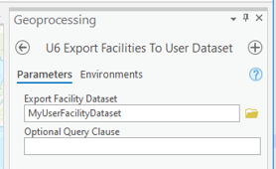The All Hazards Waste Logistics Tool includes another utility to preserve local changes that a user might make to the default facility dataset. For example, users may adjust throughput capacities or fees and exclude facilities. Any changes could otherwise be overwritten during a default data refresh unless preserved. As shown in Figure 5 above, users can access the tool by clicking “U7 Export Facilities to User Dataset.” Users can define a name and the location to which to store the exported dataset as shown in Figure 6.

Figure 6. Export Facilities to a User-Defined Dataset

## User-Defined Facilities

The All Hazards Waste Logistics Tool allows users to bring their own facility data. Strict adherence to a feature layer specification is required to use this feature. An example schema is included within the tool’s assets. Specifically, the ExampleUserData geodatabase and UserDefinedFacilities can be used as a template to create a user-defined point feature class to import into the tool. Appendix A includes a detailed listing of data fields. Generally, there is a set of fields that needs to be populated for each facility type, including:

 The example user-defined facilities included in the feature class template are not actual facilities and should not be used as input for the tool.

* Volume Liquid Daily Capacity.
* Volume Liquid Daily Capacity Units.
* Volume Solid Daily Capacity.
* Volume Solid Daily Capacity Units.

In addition, other key feature layer requirements include:

* Provide a unique facility identifier for each facility.
* Match the template field names and types for correct loading of user-defined facilities as point data.
* Designate each user-defined facility as “Disposal” or “Staging” to support resource demand calculations.
* Provide a value to indicate **volumetric** amount of solid and/or liquid waste, and corresponding units, the facility or area can take.
* The tool accepts both units of U.S. Customary as “yd3” and “gal” or Metric as “m3” and “L.”
* At present, unit abbreviations must be exact.

Two other optional attributes provide users a convenience to associate facilities with other default costing data:

* Associate the facility type ID based on the descriptions and IDs shown in Table 12 to map other default values. When a user assigns a facility type value, the tool will link other non-facility specific values that are used in computing resource demands. Facilities are required to have capacity-related data.
* Update “accepts no waste” field to “True” in order to exclude a facility or site. If the field is “False” or “Null” a facility is included for routing.

 Default throughput capacity and disposal fees are tied to facility type IDs, as shown in Tables 12 and 13. Unless users provide their own capacity data, users that load a custom facility dataset will need to map/assign a corresponding facility type ID in order for the tool to load corresponding default values used for calculations.

## Staging and Storage Locations

The All Hazards Waste Logistics Tool was designed to conveniently accept output from EPA’s Waste Staging and Storage Site Selection Tool without the need for significant pre-processing. During Step 6, the Waste Staging and Storage Site Selection Tool output (specifically the ModelOutput geodatabase) can be added as User-Defined Facilities data in the “Load Facilities to Network” geoprocessing window. Instructions in Chapter 6 provide more information on selecting and uploading the data to the All Hazards Waste Logistics Tool.

EPA’s Waste Staging and Storage Site Selection Tool allows users to identify candidate areas that are represented as a polygon and whose capacity to stage/store volumes of liquid and solid waste are calculated and output with the results, along with the centroid of the Staging Site polygon. The All Hazards Waste Logistics Tool imports these output areas and populates the “facility_waste_mgt” field as “Staging.” Additional required data are mapped and populated in the waste accepted amounts and units fields in the Facilities Network layer. Specifically, “Staging Site Facility Daily Waste Capacity” is provided as: Available Solid Waste Capacity (m3) / 90 days or Available Liquid Waste Capacity (m3) / 90 days.

 Note: The Staging Site output will always be initially designated as “Staging” in the facility_waste_mgt field. Users can manually change the waste management type in the attribute table of the Facilities layer in the “Contents” pane.

# Routing Network



5

CHAPTER

*Understand how routing resources are used within the tool*

A routing network is required to calculate both distance and travel time for routes that are identified. The tool also leverages Esri’s Network Analyst toolbox to perform network analyses.

 Facility routes are ranked based on the attributes and configuration of the network dataset selected by the user. ArcGIS Online defaults to ranking by distance. Users will need to manually adjust any rank order presented in the results output to reflect different routing priorities. Additionally, as described in Chapter 6, users can prune routes to exclude altogether.

## Network Dataset Options

The tool provides two primary options for defining the network dataset. Users must specify which of the following two methods will be used for a scenario:

* **“Pay-as-you-Go” Model**: Users will leverage Esri’s ArcGIS Online as the source for the network dataset and expend credits based on the licensing construct established for their organization. Only routing by a road mode is possible.
* **“Bring your Own Network” Model**: Users will leverage a local, file-based organizational network dataset. Typically, this option may leverage a license for Esri StreetMap Premium or a tailored network maintained by the organization that reflects local or regional specific conditions. Esri’s Network Analyst Extension is required. The tool can accommodate both road and rail in a custom network dataset.

 NOTE: For any custom network dataset, the tool requires both time and distance to perform resource demand calculations.

In version 2.0 of the tool, a custom network dataset was developed to support modeling a truck and rail network. The custom network dataset combines 2019 HERE Roads data and the Federal Railroad Administration (FRA) Rail Mainlines 2022 and FRA Rail Stations 2022 (connecting roads and mainlines) data. Access to the dataset could be restricted based on licensing requirements. For access information, users should refer to [EPA’s GitHub website](https://github.com/USEPA/Waste_Logistics_Tool) and/or the point of contact listed in Chapter 1.

 NOTE: Radioactive remote-handled waste cannot be hauled by rail. Therefore, if evaluating logistics for such waste, users must rely on a network dataset that does not include rail hauling. EPA’s custom network dataset that is available to users with adequate licensing includes rail hauling and should not be loaded if analyzing radioactive remote-handled waste.

## ArcGIS Pro License, Routing, and Network: Configuration Scenarios

The following four configuration scenarios can exist and are illustrated in Figures 7 through 11. Users will identify with one of the scenarios to better understand the relationship among key tool components.

* Configuration Scenario #1 – Named User License + “Pay-as-you-Go” Network dataset
* Configuration Scenario #2 – Named User License + “Bring your Own Network,” along with a Network Analyst license
* Configuration Scenario #3 – Concurrent Pro Licensed User without Network Analyst license but having ArcGIS Online credits

Configuration Scenario #4 – Concurrent Pro Licensed User + “Bring your Own Network,” along with a Network Analyst license

### Configuration Scenario #1

Figure 7 illustrates Configuration Scenario #1, where a user holds a named Enterprise ArcGIS Pro license and chooses the “Pay-as-you-Go” model that leverages ArcGIS Online account credits. Considerations include:

* Running the tool will use ArcGIS Online credits
* Routing solutions can be obtained with little to no effort
* Generic ArcGIS Online routing might not be optimal for heavy truck routing, but the network is expected to be current

Network dataset would not automatically reflect scenario-specific avoidance conditions

Figure 7. Configuration Scenario #1 Flow

### Configuration Scenario #2

Figure 8 illustrates Configuration Scenario #2, where a user holds a named Enterprise ArcGIS Pro license with a Network Analyst license and chooses the “Bring your own Network.” Considerations include:

* Running the tool will not use ArcGIS Online credits
* Enterprise licensing agreements for large government agencies typically include the Network Analyst license
* Network dataset might not be as good quality or current

Users can reflect scenario-specific avoidance conditions

Figure 8. Configuration Scenario #2 Flow

### Configuration Scenario #3

Figure 9 illustrates Configuration Scenario #3 (like #1 aside from extra authentication steps), where a user holds a concurrent ArcGIS Pro license without a Network Analyst license but has an ArcGIS Online account with credits. Considerations include:

* User must separately authenticate ArcGIS Pro license and ArcGIS Online account
* Running the tool will use ArcGIS Online credits
* Generic ArcGIS Online routing might not be optimal for heavy truck routing, but the network is expected to be current

Network dataset would not automatically reflect scenario-specific avoidance conditions

Figure 9. Configuration Scenario #3 Flow

### Configuration Scenario #4

Figure 10 illustrates Configuration Scenario #4, where a user holds a concurrent ArcGIS Pro license that includes the Network Analyst license and chooses the “Bring your own Network” model. Considerations include:

* Running the tool will not use ArcGIS Online credits
* Configuration most likely for smaller organizations
* Network dataset might not be as good of quality or current

Users can reflect scenario-specific avoidance conditions

Figure 10. Configuration Scenario #4 Flow

# Run the Tool



6

CHAPTER

Understand the steps that are required to run the tool and generate output

## Load Project

1. Open ArcGIS Pro.
2. As shown in Figure 11, users should sign into their ArcGIS Online (AGO) account if planning to leverage ArcGIS Online resources[9]. For EPA users, they should access their Esri Enterprise login credentials and use their portal ID or PIV card access credentials.

Figure 11. Authentication Examples

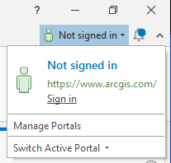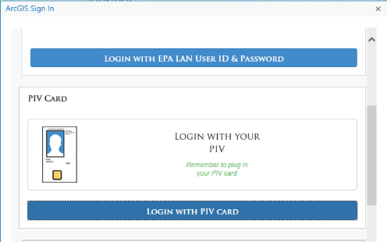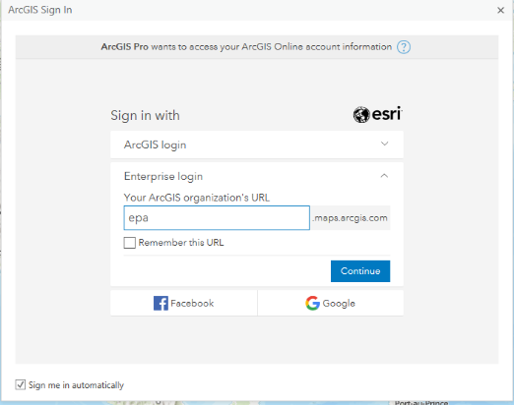

1. Navigate within ArcGIS Pro and select the All Hazards Waste Logistics Tool project (filename: *AllHazardsLogisticsTool.aprx*).
2. Three primary panes are used and can be arranged by the user:
3. Content Pane – May be summoned using the “Content” button under the “View” tab.
4. Tasks Pane – May be summoned using the "Content" button under the “View” tab[10].
5. Geoprocessing Pane – May be summoned using the “Tools” button under the “Analysis” tab.
6. If not already visible, click the “View” tab and click the Tasks icon  to open the Tasks pane. The steps to run the tool are organized in a task “Run the All Hazards Logistics Tool.”

 At any time, users can click the “Reset Panes” button under the “View” tab to restore the default mapping window setup. In addition, users are free to add additional layers to the map for reference purposes.

1. Figure 12, double-click or click the “Open Task” arrow in the Tasks pane to display the task steps. Users might need to expand the window to view the arrow.
2. Create Work Environment
3. Define Scenario
4. Set Scenario Conditions
5. Set Transporter Attributes
6. Draw Incident Area
7. Draw Support Area
8. Load Facilities to the Network
9. Draw Routing Barriers
10. Solve Routing Scenario
11. Eliminate Routes
12. Calculate Logistics Planning Estimates
13. Export Planning Results

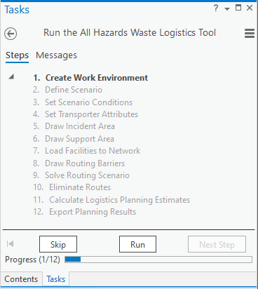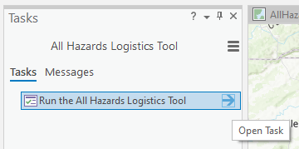

Figure 12. Open the All Hazards Waste Logistics Tool Tasks Pane

Users should move back and forth between the Tasks and the Geoprocessing panes using the “Next Step,” “Skip,” and “Run” buttons. Clicking “Run” in the Tasks pane will load related items in the Geoprocessing pane. Once selections or actions are complete in the Geoprocessing pane, user should click “Run.” The tool will alert users once actions are complete. At that point, users can click the “Next Step” or “Skip” buttons in the Tasks pane to advance to the next step in the workflow series.

## Step 1: Create Work Environment

 Processing time to build the work environment is estimated as less than two minutes.

Click the “Run” button in the bottom right of the Tasks pane to start Step 1: Create Work Environment. As shown in Figure 13, users will specify up to three key elements:

* “Project Unit System.” metric or U.S. customary units:

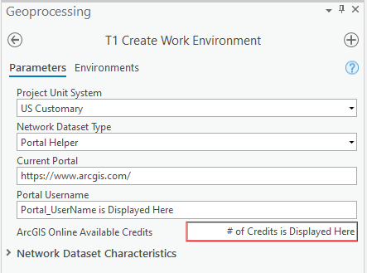

Figure 13. Create Work Environment Pane

**Metric**:

Solid Waste Volume: **m3**

Liquid Waste Volume: **L**

**US Customary**:

Solid Waste Volume: **yd3**

Liquid Waste Volume: **gal**

* “Network Dataset Type” for routing (see Chapter 5 for a detailed discussion on routing),
* “Current Portal,”
* ‘Portal Username,” and
* “ArcGIS Online Available Credits.”

This pane also includes space to display Network Dataset Characteristics. These elements are populated in Step 5 but are persistently displayed for ease of reference. These values are blank until they are initially specified. If a user loads a custom network, they should carefully inspect the items in this space and make any necessary adjustments.

 The tool assumes that most users will use ArcGIS Online credits to perform routing; therefore, the tool defaults to a setup that references [www.arcgis.com](http://www.arcgis.com) as the source for the network dataset and the user’s ArcGIS Online Account. This field value will mirror the login credentials active in the upper right corner of ArcGIS Pro. Because a user could have more than one account, this field identifies the account to which credits will be deducted for routing.

To provide additional flexibility, the tool also supports using a local network (e.g., Navteq Streets). The “Network Dataset Type” field can point to a local network dataset, if desired. Users should select “File Network Dataset” and navigate to the file location to reference the source. The tool includes logic to select trucking and rail defaults when the input is AGO or if the project is making use of a custom truckrail network dataset that may be available upon request.

Users can also modify the default characteristics of the Network Dataset that is selected. Only options that are available within the network dataset that is loaded will be available. Bolded items below that are identified by asterisks are required; however, results could be questionable if other fields are left empty. Listed below are example characteristics that are typically available:

* **Network Dataset Travel Mode\***
* **Network Impedance Field\***
* **Overall Distance Field\***
* **Overall Time Field\***

Road Distance Field

Road Time Field

Rail Distance Field

Rail Time Field

Station Count Field

Note: When using AGO, the “Travel Mode” field will initially default to “Trucking Distance.” Users can change the “Travel Mode” to any mode available within the network dataset selected.

Additionally, the tool generally expects the following combinations (with 1 and 2 most likely): 1) Road Only, 2) Road, Rail and Stations Counter, 3) Road and Rail and no Stations Counter (left blank), or 4) Rail Only.

Click the “Run” button in the bottom-right of the Geoprocessing pane to create the work environment needed to run a scenario.

Note: Running Step 1 will create a “fresh” environment. Users can alter scenario conditions and retain any adjustments made to attribute data within the current work environment to generate different results sets. Users should make a copy of the project folder if there is a desire to retain multiple projects for comparison purposes. “Save As” will only copy the environment and not the underlying data.

### Review Work Environment Settings

Users should notice that the Network Analyst extension is now visible within the project and several project components are added to the “Contents” pane as shown in Figure 14. Key project components include:

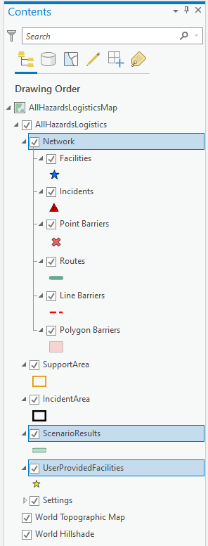

Figure . Work Environment Settings

* Network – Contains the network dataset including specifications related to facilities, the incident location, specified barriers, and routes (if any).
* Support Area – Feature class defining the geographic area from which waste management facilities can be identified.
* Incident Area – Feature class defining the incident area location.
* Scenario Results – Feature class that captures the routing and tool calculation results.
* User Provided Facilities – An empty feature class into which users can load their own custom facility dataset, conforming to the specific schema described in Chapter 4.

Settings – Contains all the reference tables used in calculations. Users can access the attribute table for each reference input and modify default values as needed. Any changes made will persist in the current, local instance of the tool. Download a new copy of the tool to start with defaults. Refer to Chapter 2 for an overview of calculations and defaults used by the tool.

For scenario “Factor Sets” (see Chapter 2), users can modify values using one of two methods (see Figure 15 for an example):

1. **Edit Settings.json File**: Users can edit the .json file directly to modify existing default values and/or create new blocks of code representing a new Factor Set. The settings.json file has three different “Factor Sets” that have reference tables used in the tool (i.e., modes, facility attributes, transporter attributes). The settings.json file is structured to make evident how these values are related.
2. **Edit via Attribute Tables**: Users can hand-edit existing values or create a new “set” of values. Users are cautioned that this process is manual and requires careful attention to properly link each set of factors with a unique objectID to relate the Factor Set. Users might find that copying an existing row and modifying values as needed is helpful. This process needs to be repeated for all related factor tables to generate a complete Factor Set. The tool does not currently contain sophisticated error checking to verify the completeness of a new Factor Set.

Right-click on any reference table and select “Attribute Table” from the Settings menu within the Contents page (see Figure 13. Create Work Environment Pane) to view the underlying data. Note: it might seem confusing to realize that the “reference tables” in the table of contents are feature classes without geometry. ArcGIS Pro does not allow tabular resources to participate in a table of content folder hierarchy, as they do not have a visible aspect. To best organize these attributes, they are treated as feature classes with an empty geometry column and no symbology to mimic a table.

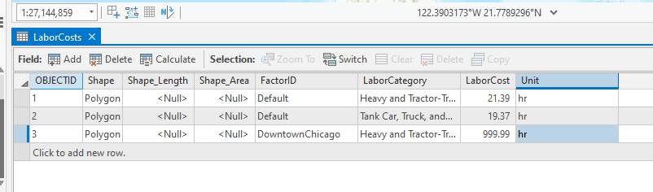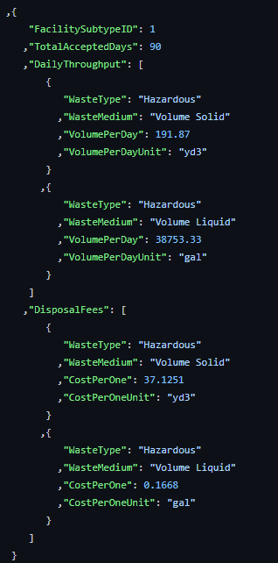

Figure 15. Edit Factor Set Example

 Advanced editing via Attribute tables is only recommended for users with the requisite skills to correctly relate a set of linked data elements. Users should also be mindful of the unit system selected to be sure new entries are normalized to the right units.

From the Tasks pane, click the “Next Step” button at the bottom of the Tasks pane to advance to Step 2.

## Step 2: Define Scenario

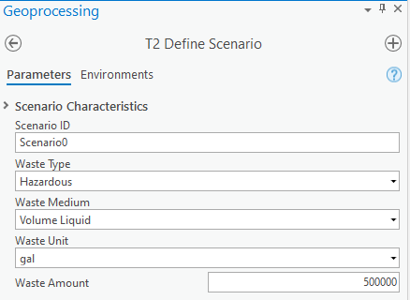

Figure 16. Define Scenario Pane

Click the “Run” button in the Tasks pane to start Step 2. In this step users will define scenario parameters as shown in Figure 16 and listed below:

* **Scenario ID** – A system-generated ID is created that can be changed to a more meaningful name to identify the scenario.
* **Waste Type** – Choose from one of seven waste types included in the tool: Radioactive Contact-Handled (solid or liquid), Radioactive Remote-Handled (solid or liquid), Low-Activity Radioactive Waste (solid), Hazardous Waste (solid or liquid), Municipal Solid Waste (MSW) (solid), Construction and Demolition (solid) waste, or Non-Hazardous Aqueous Liquid.
* **Waste Medium** – Specify the corresponding waste medium (Volume Liquid or Volume Solid) associated with the waste type selected. Only valid options are available for selection for each waste type (e.g., only solid MSW waste is addressed by the tool).

 All waste amounts in the tool are handled on a volumetric basis.

* **Waste Unit** – Valid units will automatically be specified correlating with the selections made when creating the work environment in Task 1.

**Waste Amount (Volume)** – Specify the numeric quantity (no commas).

Refer to Table 12 and Table 13 for a quick reference to waste types and medium. Click the “Run” button in the bottom-right of the Geoprocessing pane to apply the scenario parameters. Click the “Next Step” button located in the bottom-right corner of the Tasks pane to advance to Step 3.

 Users must run separate scenarios for different waste types and quantities. Following completion of Step 11, users can return to Step 2 and rename the modified scenario and proceed to Step 3 within the same “session” and make modifications and assign a new Condition Set ID.

Users may subsequently analyze and compare different scenario results output externally to the tool.

## Step 3: Set Scenario Conditions

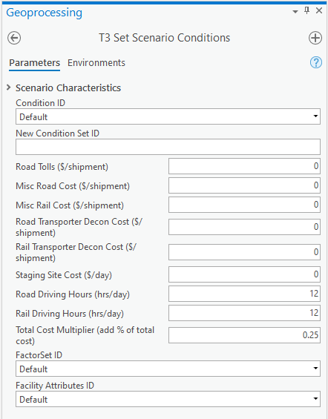

Figure 17. Set Scenario Conditions Pane

Click the “Run” button in the bottom right of the Tasks pane to start Step 3: Set Scenario Conditions. As shown in Figure 17, users can define conditions used to compute resource demands for the scenario (see Chapter 2 for information describing default values). Figure 17 illustrates the default conditions that are initially loaded. Users can adjust values and assign a new Condition Set ID to reference for future scenarios by entering a name in the “New Conditions Set ID” field.

Click the “Run” button in the bottom-right of the Geoprocessing pane to apply the scenario conditions. Click the “Next Step” button located in the bottom-right corner of the Tasks pane to advance to Step 4.

## Step 4: Set Transporter Attributes

Click the “Run” button in the bottom right of the Tasks pane to start Step 4: Set Transporter Attributes. As shown in Figure 18, users can define available transportation attributes/resources that will be used to compute resource demands for the scenario (see Chapter 2 for information describing default values). Figure 18 illustrates the default values that are initially loaded. Users can adjust values and assign a new “Transporter Attributes Name” to reference for future scenarios by entering a name in the corresponding field.

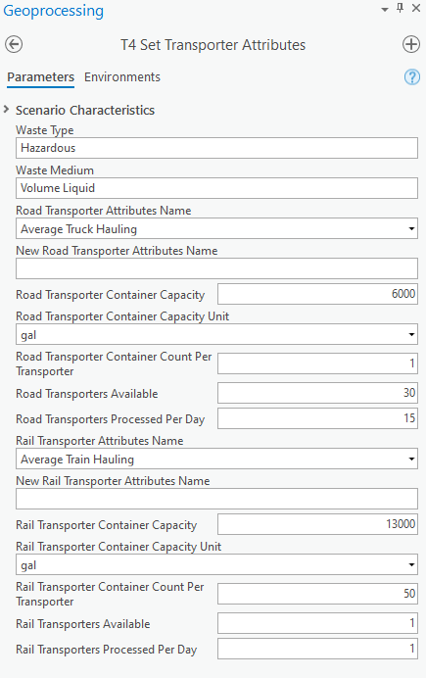

Figure 18. Set Transporter Attributes Pane

Click the “Run” button in the bottom-right of the Geoprocessing pane to apply the scenario conditions.

Click the “Next Step” button located in the bottom-right corner of the Tasks pane to advance to Step 5.

 As described in the previous section, users can edit the settings.json file to create more “sets” of data for both factors and facility attribute data. Any name value sets created in the settings.json file will be available for selection in the drop-down lists shown in .

## Step 5: Draw Incident Area

The Draw Incident Area is now active. Users will now specify the incident area using standard Esri editing tools. As shown in Figure 19, clicking the Incident Area feature class will enable the editing mode and present editing tools. Generally, users will make use of the polygon tool to draw the incident area. Draw the boundary of the incident area and click the “Next Step” button located in the bottom-right corner of the Task pane to advance to Step 6.

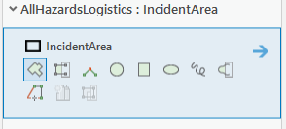

Figure 19. Draw Incident Area Controls

If the user is alerted that edits are pending in the Geoprocessing pane as shown in Figure 20, the user should click “Save” to save their sketching.



Figure 20. Save Sketching - Pending Edits Alert

## Step 6: Draw Support Area

The Draw Support Area is now active. As was done for Step 5, users will now specify the support area using standard Esri editing tools. As shown in Figure 21, clicking the Support Area feature class will enable the editing mode and present editing tools.

Selecting a support area is optional. A reasonable support area will limit the number of facilities and thus speed up routing. Users might want to select a large enough support area to access more facilities for managing waste. Defining the right size support area is a balance between including enough facilities and removing far too distant, unwanted facilities.

Generally, users will make use of the polygon tool to draw the support area. Draw the boundary of the support area and click the “Next Step” button located in the bottom-right corner of the Tasks pane to advance to Step 7.

If the user is alerted that edits are pending in the Geoprocessing pane as shown in Figure 20, the user should click “Save” to save their sketching.

Figure 21. Draw Support Area Controls

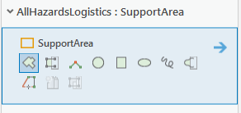

## Step 7: Load Facilities to Network

 Only facility types that accept the waste medium (liquid or solid) specified in Step 2 will be available for selection.

Click the “Run” button in the Tasks pane to start Step 7. In this step, users will load facilities to the network as shown in Figure 22 and listed below.

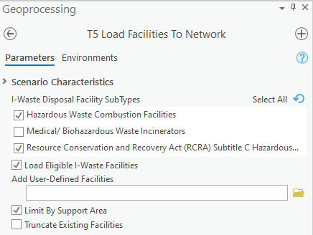

Figure 22. Load Facilities to the Network Pane

### Select Disposal Facility Types

As described in Chapter 4, the tool comes with default facility locations for the universe of facilities addressed by the tool. In this step, users can load the default facilities and/or load a user-provided set of facilities. The user should choose facility types to support waste management efforts. By default, facility types accepting the waste type specified in Step 2 are preselected; however, the tool allows users to remove facility types by unchecking unwanted facility types. The user should choose one or more facility types to include in a scenario and for which waste amounts will be allocated.

### Load I-WASTE Facilities

The tool includes a recent extract of I-WASTE facilities as a starting point. Users can choose to load I-WASTE facilities or uncheck to include only a user-defined universe of facilities.

 I-WASTE facility types determine daily throughput capacity, total waste quantity accepted, and disposal fees according to facility subtype identifiers that are explicitly defined in the tool’s reference tables. These are only estimated values and do not reflect facility-specific conditions nor agreement by the facility to accept waste.

If a user prefers to analyze only their user-defined facilities, uncheck the “Load Eligible I-WASTE Facilities” setting and follow the instructions in the next section.

Click the “Run” button in the bottom-right of the Geoprocessing pane to load the facilities into the specified support area. Click the “Next Step” button located in the bottom-right corner of the Tasks pane to advance to Step 8.

### Load User-Defined Facilities

As illustrated in Figure 23, users can add user-defined facilities by clicking on the “Browse” icon to navigate to the user-defined facility feature class of interest. Following the selection of each feature class, a new row will appear. This file input dialog accepts zero to many input files. Users should add one or more feature classes and use onscreen controls to delete any feature class. Users will need to ensure that user-provided facility data conform to the prescribed schema (see Chapter 4).

 The tool will load only facilities that correspond to the facility type selections made in the checkboxes above.

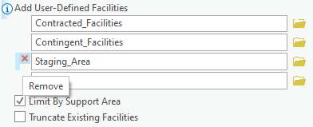

Figure 23. Add User-Defined Facilities

Users should uncheck the “Load Eligible I-WASTE Facilities” to limit facilities to only those that are user-defined. If the user is alerted that edits are pending in the Geoprocessing pane as shown in Figure 24 below, the user should click “Save” to save their sketching.



Figure 24. Save Sketching - Pending Edits Alert

Click the “Run” button in the bottom-right of the Geoprocessing pane to load the facilities into the specified support area. Step 7 can be iteratively repeated by altering choices and rerunning the Geoprocessing tool. Click the “Next Step” button located in the bottom-right corner of the Tasks pane to advance to Step 8.

### Exclude Facilities

 Users are cautioned that any changes made to “local” default facility data will persist with the tool. Users should download a new copy of the tool if original, unedited default data are preferred.

Users can exclude facilities from consideration in several ways, including:

1. Exclude the facilities layer. As discussed in earlier sections, the tool provides default facilities. Users can delete facilities as needed or load a user-defined facility data set.
2. Remove facilities after loading and before routing. As shown in Figure 14, users can view and directly manipulate the work environment. The facilities layer is located with the Network space. Users should ensure they are in editing mode and remember to save any changes (refer to Figure 24).
3. Establish barriers to control whether facilities are considered for routing by establishing barriers (see Step 8).
4. Remove any routes to those facilities after routing. Step 10 provides users with the option to eliminate routes to facilities when computing resource demands.

### Limit by Support Area

As shown in Figure 23, check “Limit by Support Area” to only display facilities located within the Support Area defined in Step 6.

### Truncate Existing Facilities

The tool initially starts with an empty facility layer; therefore, checking or unchecking this option only becomes relevant if a user is rerunning a scenario. As shown in Figure 23, the “Truncate Existing Facilities” checkbox is unchecked. If a user chooses to load facilities a second time, this control provides a way to specify whether the user prefers to start with a clean map or append additional facilities. Users might also find this feature helpful to make corrections and/or review the locations of different facility types that can be loaded into the map (i.e., if the wrong facility layer was loaded).

### Adjust Quantity Accepted and Disposal Fees

As discussed in Chapter 4, default values for various facility types are provided. Users should adjust these quantities to reflect realistic conditions if possible. Users can adjust values by:

* Editing the default GeoJSON file to change the default values assigned to a facility type that are globally applied to all facilities categorized by that facility type ID. The change would be permanent and persist with the project instance.

Creating a user-defined facility dataset based on the default inventory of facilities and adjusting facility-specific values. Users can then load the user-defined dataset reflecting facility-specific values for use in routing.

## Step 8: Draw Routing Barriers

Step 8 allows users to define routing barriers as needed. As shown in

 Users are cautioned to avoid specifying large barrier areas (and avoiding the polygon tool) when using ArcGIS Online routing or when attempting to optimize routing performance. Doing so will exclude all roads under the barriers within the routing solver that could in turn exceed established barrier limits.

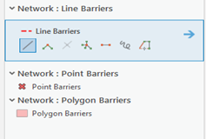Figure 25, barriers can be added to the map as points, lines, or areas using standard Esri editing tools. Click the “Next Step” button located in the bottom-right corner of the Tasks pane to advance to Step 9.

Figure 25. Draw Routing Barriers Tools

If the user is alerted that edits are pending in the Geoprocessing pane, the user should click “Save” to save their sketching.

## Step 9: Solve Routing Scenario

Step 9 invokes a Geoprocessing tool that executes the network solver task. Figure 26 illustrates key parameters for Step 9. The current Scenario ID is displayed. Users should enter a new Scenario ID if they wish to compare previous results. Doing so will create a new results dataset; otherwise, results will be overwritten.

Users are initially presented with a pre-populated quantity for the “Suggested # of Facilities to Find” parameter. This suggestion is based on the waste quantity to allocate and an average capacity of facilities within the designated support area.

 “Total Estimated Facility Capacity” is the summation of the quantity accepted amount of all facilities loaded within the designated support area. This default value is based on daily throughput capacity and a 90-day support period. This is an estimated value only and does not reflect facility-specific conditions nor agreement by the facility to accept waste.

Selecting enough facilities prior to executing the routing solver will ensure an efficient use of the routing solver. Users can adjust this number as needed. As shown in Figure 26, users can also compare the “Total Estimated Facility Capacity” to the “Waste Amount” value. If “Total Estimated Facility Capacity” is less than or close to the “Waste Amount” entered, users should consider expanding the support area to handle the full waste amount prior to running the routing solver in Step 9.

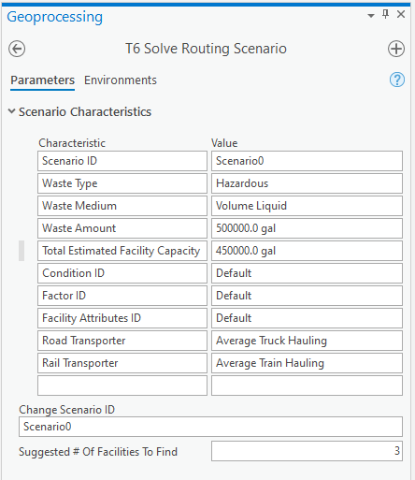

Figure 26. Solve Routing Scenario Pane

 Users relying on Esri’s ArcGIS Online Network dataset are cautioned that each submission to the network solver (i.e., whenever you click “Run” in Step 9) will use ArcGIS Online credits associated with the user account linked to this session. Users with limited credits might wish to lower the number of facilities in which to route (at the risk of not returning enough facilities to manage the specified waste quantity), while users without credit limitations could choose to increase the number of routes to consider.

Click the “Run” button on the bottom-right of the Geoprocessing pane to execute the routing solver. Click the “Next Step” button located in the bottom-right corner of the Tasks pane to advance to Step 10.

## Step 10: Eliminate Routes

Step 10 is an optional step that provides users with flexibility to prune away unwanted routes. There may be instances where more routes to facilities are returned than are needed or cases where a user needs to eliminate a route. Using standard Esri editing tools, a user can remove a route from further consideration.

Figure 27 illustrates the controls that are available. Click on the “Edit” tab and find the Features and Selection tools. Using the “Select” tool, highlight the route(s) to eliminate. From the Features tool set, click “Delete” to remove the route. Click the “Next Step” button located in the bottom-right corner of the Tasks pane to advance to Step 11.

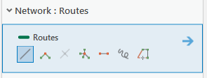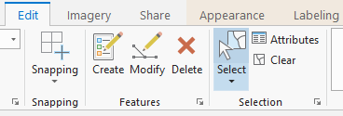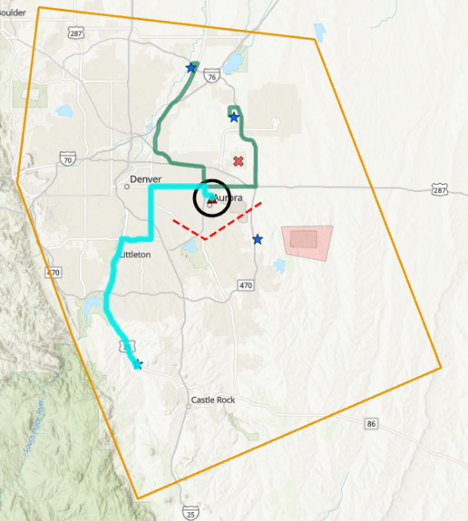

Figure 27. Eliminate Routes Editing Tools

If the user is alerted that edits are pending in the Geoprocessing pane, the user should click “Save” to save their sketching.

## Step 11: Calculate Logistics Planning Estimates

Click the “Run” button in the Tasks pane to start Step 11. This task involves running a Geoprocessing tool to execute the resource demand calculations that are described in Chapter 2. Calculated results are stored in the Scenario Results feature class. Figure 28 below illustrates the controls available in Step 11.

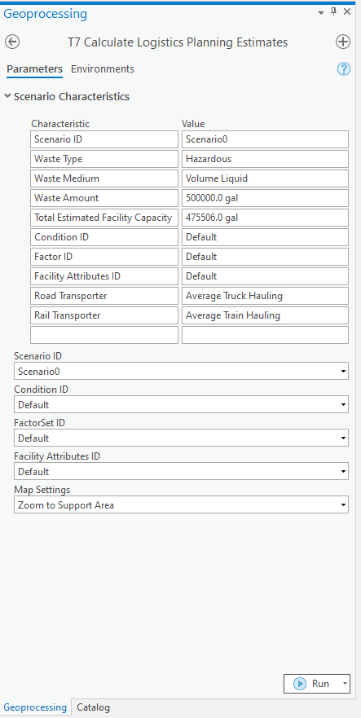

Figure 28. Calculate Logistics Planning Estimates Pane

 Be sure to compare the “Total Estimated Facility Capacity” and the “Waste Amount” values to ensure enough facilities are included to manage the quantity of waste specified. Note: The tool will remove longer routes if closer facilities satisfy the waste amount specified when calculating and preparing the results output.

### Specify Map Settings

As shown in Figure 29, the tool provides four different map settings from which to select. Each variation controls the clip of the map that is saved to include with the results output.

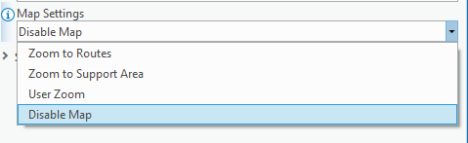

Figure 29. Map Settings

Click “Run” on the Geoprocessing pane to run the tool. Click the “Next Step” button located in the bottom-right corner of the Tasks pane to advance to Step 12.

## Step 12: Export Planning Results

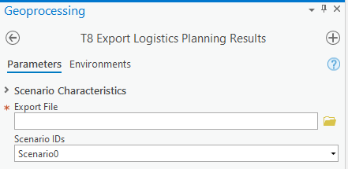Click the “Run” button in the Tasks pane to start Step 12. This task will run a geoprocessing tool to export planning results to a Microsoft Excel workbook. As shown in Figure 30. Export Logistics Planning Results Pane, users can specify a file name and the location to save results. If more than one scenario was created, users can select the Scenario ID for the results set of interest to export.

Figure 30. Export Logistics Planning Results Pane

### Results Output

The tool exports results calculated in Step 12 and saves output into a Microsoft Excel workbook. Refer to Chapter 2 for information on the calculations. The workbook includes three tabs:

* **Summary** – Provides an aggregated view of the amount of waste (allocated and unallocated, if any), a breakdown of costs, and a total cost amount.
* [**ScenarioName**] – Follows the naming convention specified by the user, provides a summary of the scenario and specific facility routing details, and includes a snapshot of the image if option enabled by the user.
* **Reference** – Provides access to underlying values used in the calculations.

Results for individual scenarios will be exported separately. Users can pull worksheets into a single workbook to facilitate comparisons and track how differences in scenario conditions and/or factors affect results.

Results for individual scenarios will be exported separately. Users can pull worksheets into a single workbook to facilitate comparisons and track how differences in scenario conditions and/or factors affect results.

### Create and Compare More than One Scenario

After completing Step 12 for a specific scenario, users can create additional scenarios to support comparative analyses. For example, a user might want to assess resource and/or logistical tradeoffs if waste is handled as MSW versus hazardous. Users can return to any steps previously completed to make adjustments. To preserve the adjustments for comparison purposes, the user should assign unique Scenario, Condition, and FactorSet IDs. Step 11 allows users to specify which ID should be referenced when calculating results. Users can make selections using the drop-down menus that are available in the pane.

# Troubleshooting



7

7

CHAPTER

CHAPTER

Read about issues and resolutions to common problems

This chapter provides solutions to commonly found problems that users might encounter using the tool. It is recommended that users confirm software and hardware compatibility (information found in Chapter 3 of this document) before continuing.

| **Problem** | **Cause** | **Remedy** |
| --- | --- | --- |
| Alert: Edits are Pending | Layers were edited but not explicitly saved. | Look for the alert in the Geoprocessing pane and click “Save” to save sketching. |
| User-defined facilities will not load or are not included in results | Required data fields and acceptable values are not correctly specified. | Verify required fields are correctly populated with acceptable values and confirm no typos exist for expected values. Check field property types and layer attributes for spelling mistakes or spaces (e.g., “Treu” instead of “True” or “m 3” instead of “m3”). |
| Number of Facilities to Find is blank | Support area does not have facilities. | Expand support area in Step 6 or uncheck “Limit by Support Area” in Step 7. |
| Solve Routing Scenario Failed | When using the ArcGIS Online network and routing solution, the maximum number of barriers that can be solved is 500. | Reduce support area and/or number of barriers and re-run routing solver. |
| Scratch database becomes bloated | Interim results are stashed in the scratch database. | Periodically empty the scratch database. |

This concludes the User’s Guide. If users have any questions, please email the point of contact listed in Chapter 1.

**APPENDIX A**

Facility schema for defining values to define a facility and support resource demand calculations.

**Table A-1. Facility Schema**

|  |  |  |
| --- | --- | --- |
| Field Name | Field Type | Description |
| facility_identifier* | Text | Unique identifier code from source data. |
| facility_typeid | Long | I-WASTE Type Identifier. |
| facility_subtypeids | Text | I-WASTE Subtype Identifiers provided as a comma-delimited list (see Tables 12 and 13). |
| facility_name | Text | The common name by which is facility is best known. |
| facility_address | Text | Facility street address, might or might not geocode to the actual site. |
| facility_city | Text | Facility city. |
| facility_state | Text | Facility state. |
| facility_zip | Text | Facility zip. |
| facility_telephone | Text | Facility phone information if available. |
| front_gate_longitude | Double | Optional precise longitude ordinate in WGS84 indicating an exact location from which to begin routing (e.g., a preferred gate). |
| front_gate_latitude | Double | Optional precise latitude ordinate in WGS84 indicating an exact location from which to begin routing (e.g., a preferred gate). |
| facility_waste_mgt* | Text | Identifies whether facility is used to “stage” waste or “dispose” waste. |
| facility_accepts_no_waste | Text | Facility Accepts No Waste Flag. |
| fac_radc_solid_dly_cap | Double | Facility Radioactive: Contact-Handled Volume Solid Daily Capacity. |
| fac_radc_solid_dly_cap_unt | Text | Facility Radioactive: Contact-Handled Volume Solid Daily Capacity Unit. |
| fac_radc_liquid_dly_cap | Double | Facility Radioactive: Contact-Handled Volume Liquid Daily Capacity. |
| fac_radc_liquid_dly_cap_unt | Text | Facility Radioactive: Contact-Handled Volume Liquid Daily Capacity Unit. |
| fac_radr_solid_dly_cap | Double | Facility Radioactive: Remote-Handled Volume Solid Daily Capacity. |
| fac_radr_solid_dly_cap_unt | Text | Facility Radioactive: Remote-Handled Volume Solid Daily Capacity Unit. |
| fac_radr_liquid_dly_cap | Double | Facility Radioactive: Remote-Handled Volume Liquid Daily Capacity. |
| fac_radr_liquid_dly_cap_unt | Text | Facility Radioactive: Remote-Handled Volume Liquid Daily Capacity Unit. |
| fac_larw_solid_dly_cap | Double | Facility Low-Activity Radioactive Waste Volume Solid Daily Capacity. |
| fac_larw_solid_dly_cap_unt | Text | Facility Low-Activity Radioactive Waste Volume Solid Daily Capacity Unit. |
| fac_haz_solid_dly_cap | Double | Facility Hazardous Volume Solid Daily Capacity. |
| fac_haz_solid_dly_cap_unt | Text | Facility Hazardous Volume Solid Daily Capacity Unit. |
| fac_haz_liquid_dly_cap | Double | Facility Hazardous Volume Liquid Daily Capacity. |
| fac_haz_liquid_dly_cap_unt | Text | Facility Hazardous Volume Liquid Daily Capacity Unit. |
| fac_msw_solid_dly_cap | Double | Facility Municipal Solid Waste (MSW) Volume Solid Daily Capacity. |
| fac_msw_solid_dly_cap_unt | Text | Facility Municipal Solid Waste (MSW) Volume Solid Daily Capacity Unit. |
| fac_cad_solid_dly_cap | Double | Facility Construction and Demolition Volume Solid Daily Capacity. |
| fac_cad_solid_dly_cap_unt | Text | Facility Construction and Demolition Volume Solid Daily Capacity Unit. |
| fac_nhaq_liquid_dly_cap | Double | Facility Non-Hazardous Aqueous Waste Volume Liquid Daily Capacity. |
| fac_nhaq_liquid_dly_cap_unt | Text | Facility Non-Hazardous Aqueous Waste Volume Liquid Daily Capacity Unit. |
| fac_radc_solid_tot_acp | Double | Facility Radioactive: Contact-Handled Volume Solid Total Acceptance. |
| fac_radc_solid_tot_acp_unt | Text | Facility Radioactive: Contact-Handled Volume Solid Total Acceptance Unit. |
| fac_radc_liquid_tot_acp | Double | Facility Radioactive: Contact-Handled Volume Liquid Total Acceptance. |
| fac_radc_liquid_tot_acp_unt | Text | Facility Radioactive: Contact-Handled Volume Liquid Total Acceptance Unit. |
| fac_radr_solid_tot_acp | Double | Facility Radioactive: Remote-Handled Volume Solid Total Acceptance. |
| fac_radr_solid_tot_acp_unt | Text | Facility Radioactive: Remote-Handled Volume Solid Total Acceptance Unit. |
| fac_radr_liquid_tot_acp | Double | Facility Radioactive: Remote-Handled Volume Liquid Total Acceptance. |
| fac_radr_liquid_tot_acp_unt | Text | Facility Radioactive: Remote-Handled Volume Liquid Total Acceptance Unit. |
| fac_larw_solid_tot_acp | Double | Facility Low-Activity Radioactive Waste Volume Solid Total Acceptance. |
| fac_larw_solid_tot_acp_unt | Text | Facility Low-Activity Radioactive Waste Volume Solid Total Acceptance Unit. |
| fac_haz_solid_tot_acp | Double | Facility Hazardous Volume Solid Total Acceptance. |
| fac_haz_solid_tot_acp_unt | Text | Facility Hazardous Volume Solid Total Acceptance Unit. |
| fac_haz_liquid_tot_acp | Double | Facility Hazardous Volume Liquid Total Acceptance. |
| fac_haz_liquid_tot_acp_unt | Text | Facility Hazardous Volume Liquid Total Acceptance Unit. |
| fac_msw_solid_tot_acp | Double | Facility Municipal Solid Waste (MSW) Volume Solid Total Acceptance. |
| fac_msw_solid_tot_acp_unt | Text | Facility Municipal Solid Waste (MSW) Volume Solid Total Acceptance Unit. |
| fac_cad_solid_tot_acp | Double | Facility Construction and Demolition Volume Solid Total Acceptance. |
| fac_cad_solid_tot_acp_unt | Text | Facility Construction and Demolition Volume Solid Total Acceptance Unit. |
| fac_nhaq_liquid_tot_acp | Double | Facility Non-Hazardous Aqueous Waste Volume Liquid Total Acceptance. |
| fac_nhaq_liquid_tot_acp_unt | Text | Facility Non-Hazardous Aqueous Waste Volume Liquid Total Acceptance Unit. |
| fac_radc_solid_dis_fee | Double | Facility Radioactive: Contact-Handled Volume Solid Disposal Fees. |
| fac_radc_solid_dis_fee_unt | Text | Facility Radioactive: Contact-Handled Volume Solid Disposal Fees Unit. |
| fac_radc_liquid_dis_fee | Double | Facility Radioactive: Contact-Handled Volume Liquid Disposal Fees. |
| fac_radc_liquid_dis_fee_unt | Text | Facility Radioactive: Contact-Handled Volume Liquid Disposal Fees Unit. |
| fac_radr_solid_dis_fee | Double | Facility Radioactive: Remote-Handled Volume Solid Disposal Fees. |
| fac_radr_solid_dis_fee_unt | Text | Facility Radioactive: Remote-Handled Volume Solid Disposal Fees Unit. |
| fac_radr_liquid_dis_fee | Double | Facility Radioactive: Remote-Handled Volume Liquid Disposal Fees. |
| fac_radr_liquid_dis_fee_unt | Text | Facility Radioactive: Remote-Handled Volume Liquid Disposal Fees Unit. |
| fac_larw_solid_dis_fee | Double | Facility Low-Activity Radioactive Waste Volume Solid Disposal Fees. |
| fac_larw_solid_dis_fee_unt | Text | Facility Low-Activity Radioactive Waste Volume Solid Disposal Fees Unit. |
| fac_haz_solid_dis_fee | Double | Facility Hazardous Volume Solid Disposal Fees. |
| fac_haz_solid_dis_fee_unt | Text | Facility Hazardous Volume Solid Disposal Fees Unit. |
| fac_haz_liquid_dis_fee | Double | Facility Hazardous Volume Liquid Disposal Fees. |
| fac_haz_liquid_dis_fee_unt | Text | Facility Hazardous Volume Liquid Disposal Fees Unit. |
| fac_msw_solid_dis_fee | Double | Facility Municipal Solid Waste (MSW) Volume Solid Disposal Fees. |
| fac_msw_solid_dis_fee_unt | Text | Facility Municipal Solid Waste (MSW) Volume Solid Disposal Fees Unit. |
| fac_cad_solid_dis_fee | Double | Facility Construction and Demolition Volume Solid Disposal Fees. |
| fac_cad_solid_dis_fee_unt | Text | Facility Construction and Demolition Volume Solid Disposal Fees Unit. |
| fac_nhaq_liquid_dis_fee | Double | Facility Non-Hazardous Aqueous Waste Volume Liquid Disposal Fees. |
| fac_nhaq_liquid_dis_fee_unt | Text | Facility Non-Hazardous Aqueous Waste Volume Liquid Disposal Fees Unit. |
| C_D Accepted* | Text | Indication [acceptable value = True or False] that facility accepts construction and demolition (C&D) waste. |
| MSW_accepted* | Text | Indication that facility accepts municipal solid waste (MSW). [True/False] |
| HW_accepted* | Text | Indication that facility accepts hazardous waste. [True/False] |
| LARWRad_accepted* | Text | Indication that facility accepts LARW waste. [True/False] |
| RAD_accepted* | Text | Indication that facility accepts radioactive waste. [True/False] |
| NHAW_accepted | Text | Indication that facility accepts non-hazardous aqueous waste. |
| date_stamp | Date | The date on which facility data were extracted from primary source or created by the user. Optional. |
| source | Text | The primary source originating the data. Optional. |
| notes | Text | User-specified notes. Optional. |

* Indicates required fields for tool to execute

U.S. Environmental Protection Agency

Homeland Security Research Program

Research Triangle Park, NC 27711

1. U.S. Environmental Protection Agency, “Planning for Natural Disaster Debris” Office of Resource Conservation and Recovery, Washington, DC, EPA 530-F-19-003, April 2019.  
   
2. EPA Decision Support Tools for Waste Management, <https://www.epa.gov/emergency-response-research/decision-support-tools-waste-management>.
3. <https://github.com/USEPA/Waste_Staging_Tool>
4. 4 Miscellaneous Costs and Total Cost Multiplier inputs provide users with flexibility to account for extra costs that might be assessed in transporting CBRN-related waste given the likelihood that “normal” costs would be increased.
5. Fixed unit transportation cost units will vary depending on waste type and transport mode. Units can be by volume, time, or container.
6. Only a subset of facility data available within I-WASTE is included with the All Hazards Waste Logistics Tool.
7. Some facilities can accept more than one waste type (e.g., MSW and C&D).
8. I-WASTE Universe of Facilities source information, <https://iwaste.epa.gov/guidance/universe-of-facilities>.
9. Refer to Chapter 5 for more details on different access configurations.
10. The Tasks pane is used to guide the user through the necessary steps to operate the tool.